

FACULTY OF ENGINEERING AND TECHNOLOGY

A REPORT ABOUT ALGORITHM DEVELOPMENT ON NUMERICAL APPROXIMATE METHODS AND SOLVING DIFFERENTIAL EQUATIONS

COURSE UNIT: COMPUTER PROGRAMMING
LECTURER: MR. MASERUKA BENEDICTO
GROUP 13
SUBMITTED BY
NAME | COURSE | REG. NO.
NYEMERA ANNA GRACE | AMI | BU/UP/2024/0838
NASASIRA AUSTINE | WAR | BU/UP/2024/1048
BARASA ELVIS | AMI | BU/UP/2024/3817
BRAVO GIFT | PTI | BU/UG/2024/5059
NAMUWAWU PATRICIA | APE | BU/UG/2024/2670
AINAMATSIKO JEREMIAH | WAR | BU/UP/2024/3826
ACHAM LOYCE | AMI | BU/UP/2024/0821
MUGUME MATHIAS | MEB | BU/UP/2024/0983
ABUROT MARTHA | WAR | BU/UP/2024/3823
KINTU GADAFFI | AMI | BU/UP/2024/3734

DATE OF SUBMISSION: ……………………………… i

DECLARATION
We hereby certify and confirm that the information in this report is out of our own efforts, research and it has never been submitted in any institution for any academic award
NAME SIGNATURE
- NASASIRA AUSTINE …………………………
- KINTU GADAFI ………………………..
- ABUROT MARTHA …………………………
4. MUGUME MATHIAS ………………………….
5. ACHAM LOYCE ………………………….
- AINAMATSIKO JEREMIAH ………………………….
- NAMUWAWU PATRICIA …………………………..
- BRAVO GIFT …………………………..
9. NYEMERA ANNA GRACE …………………………..
10. BARASA ELVIS …………………………..

APPROVAL
We are presenting this report which has been written and produced under our efforts. We carried out research on different numerical methods and developed algorithms to solve the data.

ACKNOWLEDGEMENT
First and foremost, we would like to thank the Almighty God for giving us the strength to carry on with our research as Group 13. We would love to extend our gratitude to all the persons with whose help we managed to make it this far
The willingness of each one of us to invest time and provide constructive feedback has been immensely valuable in this assignment.
Finally, we would like to express our gratitude to all the sources and references that have been cited in this report

DEDICATION.
We dedicate this report to all the individuals especially Group 13 members, who have been there for us in the process of formulating and producing this report.
To our lecturer Mr. Maseruka Benedicto whose guidance and expertise have been invaluable, your mentorship and insightful feedback have shaped our understanding.

ABSTRACT
We started our research from 27th September, 2025 in the university library with division of work for intense research in the different sections, where were obtained the best ways of how to do the assignment and that are used in the engineering field to solve problems.
Information we used was mainly obtained from YouTube tutorials. We carried out research on Newton’s Raphson method, Secant, Euler and Runge kurta. The division of work, eased the work and saved time.

1 CHAPTER ONE: INTRODUCTION
1.1 Background.
MATLAB, which stands for matrix laboratory, is a high-performance programming language and environment designed primarily for technical computing. Its origins trace back to the late 1970s when Cleve Moler, a professor of computer science, developed it to provide his students with easy access to mathematical software libraries without requiring them to learn Fortran.
1.2 Historical Development
Early Development (1970s)
- Origins in Matrix Algebra: MATLAB's foundation was built on research papers by J. H. Wilkinson and others, focusing on algorithms for solving matrix linear equation and eigenvalue problems.
- Academic Tool: Cleve Moler, a mathematics professor, developed the initial Fortran-based version in the 1970s as a free, interactive tool for his students, called the "Matrix Laboratory".
- Basis in LINPACK and EISPACK: This early version used subroutines from the LINPACK and EISPACK matrix software libraries for solving linear equations and eigenvalue problems.
Commercialization and Expansion (1980s)
- Commercial Launch: In 1984, Cleve Moler and John N. Little commercialized the software, founding MathWorks to market it to engineers and scientists.
- Rewritten in C: The commercial version was a significant rewrite of the original Fortran code, incorporating a proper programming language, user functions, and graphics capabilities.
- Toolboxes: Early toolboxes were introduced, including the Control System Toolbox (1985) and the Signal Processing Toolbox (1987), significantly expanding MATLAB's capabilities.
Continued Evolution (1990s to Present)
- Advanced Data Structures: The introduction of sparse matrices in 1992 and toolboxes like Image Processing and Symbolic Math in 1993 marked further advancements.
- Broadened Scope: While initially focused on numerical linear algebra, MATLAB evolved into a comprehensive technical computing environment for a wide range of applications.
- Modern Capabilities: Today, MATLAB supports advanced features such as parallel computing, object-oriented programming, and extensive integration with other languages and platform. It has also introduced features like the Live Editor, which allows users to create interactive documents that combine code, output, and formatted text. This evolution reflects MATLAB's ongoing adaptation to meet the needs of its diverse user base across academia and industry.
MATLAB AND NUMERICAL METHODS
MATLAB is a powerful tool for solving numerical problems. Below are some common numerical methods and how they can be implemented in MATLAB:
- Newton’s Raphson method
- Secant
- Euler
- Heun
- Fixed point iteration
- bisection
- Runge kurta
Numerical methods are essential techniques used to solve mathematical problems that are difficult or impossible to solve analytically. MATLAB is a powerful tool that uses numerical analysis with its graphical and computational capabilities, making it an ideal platform for implementing numerical methods.
Some of the real-life applications of numerical methods
- Estimating ocean currents
- Modelling combustion flow in coal power plants
- Simulating airflow over airplane bodies.

CHAPTER 2: STUDY METHODOLOGY
2:1 Introduction
At the start time of the research, we divided ourselves accordingly to enable easy understanding of work and great participation of members in the assignment. The groups organized discussions and discussed their findings to the entire group after thorough research.
2.2 Discussion chapter
MATLAB Tools and Environment
All members were encouraged to know how to use the MATLAB Tools and study its environment to be well conversant with it. Some of the keynotes members were advised to observe are as follows
- Become familiar with the MATLAB desktop environment, including the Current Folder, Command Window, and Workspace.
- Explore and use the various apps available in MATLAB for different tasks, depending on your installed toolboxes.
Code Quality and Maintainability
When generating the code the members came to a conclusion to follow certain guidelines as mentioned below;
- Focus on producing code that is more likely to be correct.
- Make your code readable to others and yourself by using meaningful variable names and consistent formatting.
- Provide comments and explanations within your code to help with future maintenance and understanding.
- Incorporate testing into your development process to ensure code functionality and reliability.

CHAPTER THREE: TASKS
The tasks that were done were done included utilizing the knowledge of algorithms development, control structures and modules 1-4 on the following problems
- All Numerical approximate methods for finding the solutions to functions, these include but are not limited to; newton Raphson
- All methods for solving differential equations numerically these include but are not limited to; Euler, Runge kutta
Generating of the codes
When generating the codes, we followed the specific steps for it to run;
Steps to Solve a Numerical Method in MATLAB
1. Define the Problem
- Clearly stated the mathematical problem to solve.
- For example, if solving a non-linear equation, define it as a function, e.g.,
f(x)=x²−4
f(x)=x²−4.
2. Choose the Appropriate Numerical Method
3. Set Up the MATLAB Code
- Write the function or script to implement the numerical method:
  - Define the function or system of equations.
  - Specify initial guesses, intervals, or parameters as required.
4. Provide Necessary Inputs
- Input parameters such as:
  - Initial guesses for iterative methods.
  - Tolerances for convergence.
5. Execute and Analyse Results
- Run the MATLAB script or function.
- Check the output for accuracy and convergence.
- Visualize results if needed using plots.
6. Validate and Refine
- Validate the solution by substituting it back into the original equation.
- Refine the solution by adjusting tolerances or using alternative methods if necessary.
The code structures
Defining the different parameters used in the different methods
%% Root Finding Methods Implementation

% Define function and its derivative for testing
f = @(x) x.^3 - 2*x - 5;
df = @(x) 3*x.^2 - 2;

f2 = @(x) exp(-x) - x;
df2 = @(x) -exp(-x) - 1;

% Test parameters
x0 = 2.0; % Initial guess for Newton
x1 = 1.0; % Second guess for Secant
a = 1.0; b = 3.0; % Interval for Bisection
tol = 1e-8;
max_iter = 100;

NEWTON RAPHSON METHOD
THE FLOW CHART
start
n=0,1,2,3...N
Read; X₀
Compute, $f(x_{n})$, $f'(x_{n})$
Compute,
Tol = $1/2$×10^{N}
$x_{n+1}=x_{n}-$ $\frac{f(x_{n})}{f'(x_{n})}$
$${[x}_{n+1}-x_{n}]<tol$$
Print, $x_{n+1}$
Stop
$$n=n+1$$
$$x_{n}{=x}_{n+1}$$
yes
no

PSEUDOCODE
FUNCTION newtonRaphson(f, f_prime, x0, tolerance, max_iterations)
f: function
f_prime: derivative of function
x0: initial guess
tolerance: convergence criteria
max_iterations: maximum number of iterations

x = x0
iteration = 0

WHILE iteration < max_iterations
fx = f(x)
fpx = f_prime(x)

Check if derivative is zero to avoid division by zero
IF abs(fpx) < 1e-10 THEN
PRINT "Derivative too small. Method may fail."
RETURN null
END IF

Newton-Raphson formula
x_new = x - fx / fpx

Check convergence
IF abs(x_new - x) < tolerance THEN
RETURN x_new
END IF

x = x_new
iteration = iteration + 1
END WHILE

PRINT "Maximum iterations reached"
RETURN x
END FUNCTION
ACTUAL CODE
%% Newton-Raphson Method
function [root, iterations, history, comp_time] = newton_raphson(f, df, x0, tol, max_iter)
tic;
history = zeros(max_iter, 1);
x = x0;
iterations = 0;

for i = 1:max_iter
fx = f(x);
dfx = df(x);

if abs(dfx) < eps
warning('Derivative too small');
break;
end

x_new = x - fx / dfx;
history(i) = x_new;

if abs(x_new - x) < tol
iterations = i;
break;
end

x = x_new;
iterations = i;
end

history = history(1:iterations);
root = x;
comp_time = toc;
end

SECANT METHOD
FLOW CHART
start
n=0,1,2,3...N
Read; $x_{0}$
Compute, $f(x_{n})$, ${f(x}_{n-1})$,
Compute,
Tol = $1/2$×10^{N}
$x_{n+1}=x_{n}-$ $\frac{f(x_{n})(x_{n}-x_{n-1})}{f\left(x_{n}\right)-{f(x}_{n-1})}$
$${[x}_{n+1}-x_{n}]<tol$$
Print, $x_{n+1}$
Stop
$$n-1=n$$
$$x_{n-1}{=x}_{n}$$
yes
no

PSUEDOCODE
FUNCTION secantMethod(f, x0, x1, tolerance, max_iterations)
f: function
x0, x1: two initial guesses
tolerance: convergence criteria
max_iterations: maximum number of iterations

x_prev = x0
x_curr = x1
iteration = 0

WHILE iteration < max_iterations
f_prev = f(x_prev)
f_curr = f(x_curr)

Avoid division by zero
IF abs(f_curr - f_prev) < 1e-10 THEN
PRINT "Denominator too small. Method may fail."
RETURN null
END IF

Secant method formula
x_next = x_curr - f_curr * (x_curr - x_prev) / (f_curr - f_prev)

Check convergence
IF abs(x_next - x_curr) < tolerance THEN
RETURN x_next
END IF

Update for next iteration
x_prev = x_curr
x_curr = x_next
iteration = iteration + 1
END WHILE

PRINT "Maximum iterations reached"
RETURN x_curr
END FUNCTION
ACTUAL CODE
%% Secant Method
function [root, iterations, history, comp_time] = secant_method(f, x0, x1, tol, max_iter)
tic;
history = zeros(max_iter, 1);
x_prev = x0;
x_curr = x1;
iterations = 0;

for i = 1:max_iter
f_prev = f(x_prev);
f_curr = f(x_curr);

if abs(f_curr - f_prev) < eps
warning('Function values too close');
break;
end

x_new = x_curr - f_curr * (x_curr - x_prev) / (f_curr - f_prev);
history(i) = x_new;

if abs(x_new - x_curr) < tol
iterations = i;
break;
end

x_prev = x_curr;
x_curr = x_new;
iterations = i;
end

history = history(1:iterations);
root = x_curr;
comp_time = toc;
end

SOLVING ORDINARY DIFFERENTIAL EQUATIONS
EULER METHOD
Flow chart
for $i=1:n$
If ${x<x}_{n}$
Print, $x_{0}, y_{0}$
Read, $x_{0},y_{0},h,x_{n}$
start
stop
$$F\left(x,y\right)=(x-y)/(x+y)$$
$$y=y_{0}+h*F(x_{0},y_{0})$$
$$x=x+h$$
$$n=(x_{n}-x_{0})/(h+1)$$
$$x_{0}=x$$
$$y_{0}=y$$

PSUEDOCODE
FUNCTION eulerMethod(f, x0, y0, h, n_steps)
f: dy/dx = f(x, y)
x0, y0: initial conditions
h: step size
n_steps: number of steps to compute

x = x0
y = y0

Initialize results array
results = [(x, y)]

FOR i = 1 TO n_steps
// Euler's method formula
y = y + h * f(x, y)
x = x + h

// Store result
results.append((x, y))
END FOR
RETURN results
END FUNCTION

ACTUAL CODE
%% Euler Method
function [t, y, comp_time] = euler_method(f, tspan, y0, h)
tic;
t = tspan(1):h:tspan(2);
n = length(t);
y = zeros(length(y0), n);
y(:,1) = y0(:);

for i = 1:n-1
y(:,i+1) = y(:,i) + h * f(t(i), y(:,i));
end
comp_time = toc;
end

RUNGE KUTTA
THE FLOW CHART
start
m=0,1,2,3...N
Read; $x_{0},y_{0},a,b,h,N$
Compute, $k_{1}$, $k_{2},k_{3} and k_{4}$
Compute, Tol = $1/2$×10^{N}
$$m-1, a→x_{m}, y_{0}→y_{m}$$
$$x_{m}+h→x_{m}$$
$$y_{m}+\frac{1}{6}(k_{1}+2k_{2}+2k_{3}+k_{4})→y_{m}$$
$$x_{m}≥b$$
Print, $x_{m},y_{m}$
Stop
yes
no

PSEUDOCODE
FUNCTION rungeKutta4(f, x0, y0, h, n_steps)
f: dy/dx = f(x, y)
x0, y0: initial conditions
h: step size
n_steps: number of steps to compute

x = x0
y = y0

Initialize results array
results = [(x, y)]

FOR i = 1 TO n_steps
Calculate the four slopes
k1 = h * f(x, y)
k2 = h * f(x + h/2, y + k1/2)
k3 = h * f(x + h/2, y + k2/2)
k4 = h * f(x + h, y + k3)

Weighted average of slopes
y = y + (k1 + 2*k2 + 2*k3 + k4) / 6
x = x + h
Store result
results.append((x, y))
END FOR

RETURN results
END FUNCTION
ACTUAL CODE
%% Runge-Kutta 4th Order
function [t, y, comp_time] = rk4_method(f, tspan, y0, h)
tic;
t = tspan(1):h:tspan(2);
n = length(t);
y = zeros(length(y0), n);
y(:,1) = y0(:);

for i = 1:n-1
k1 = h * f(t(i), y(:,i));
k2 = h * f(t(i) + h/2, y(:,i) + k1/2);
k3 = h * f(t(i) + h/2, y(:,i) + k2/2);
k4 = h * f(t(i) + h, y(:,i) + k3);

y(:,i+1) = y(:,i) + (k1 + 2*k2 + 2*k3 + k4) / 6;
end
comp_time = toc;
end

Heun's Method
Is also known as the Improved Euler Method, is a numerical technique used to approximate solutions to ordinary differential equations (ODEs).
The formula for Heun's Method is given by:
$$yn+1​=yn​+2h​(f(xn​,yn​)+f(xn​+h,yn​+hf(xn​,yn​)))$$
CODE FOR HEUN’S METHOD
%% Improved Euler Method (Heun's)
function [t, y, comp_time] = improved_euler(f, tspan, y0, h)
tic;
t = tspan(1):h:tspan(2);
n = length(t);
y = zeros(length(y0), n);
y(:,1) = y0(:);

for i = 1:n-1
k1 = f(t(i), y(:,i));
k2 = f(t(i) + h, y(:,i) + h * k1);
y(:,i+1) = y(:,i) + (h/2) * (k1 + k2);
end
comp_time = toc;
end

REAL WORLD PROBLEMS
PROBLEM ONE
%% REAL WORLD PROBLEM 1: Population Growth with Carrying Capacity
fprintf('=== PROBLEM 1: Population Growth with Carrying Capacity ===\n');

% Logistic growth equation: dP/dt = r*P*(1 - P/K)
r = 0.1; % Growth rate
K = 1000; % Carrying capacity
P0 = 100; % Initial population

logistic_ode = @(t, P) r * P * (1 - P/K);

% Analytical solution
t_analytical = linspace(0, 100, 1000);
P_analytical = K ./ (1 + ((K - P0)/P0) * exp(-r * t_analytical));

% Numerical solutions
h = 1.0;
tspan = [0, 100];

% Solve with different methods
[t_euler, P_euler, time_euler] = euler_method(logistic_ode, tspan, P0, h);
[t_rk4, P_rk4, time_rk4] = rk4_method(logistic_ode, tspan, P0, h);
[t_improved, P_improved, time_improved] = improved_euler(logistic_ode, tspan, P0, h);

% Calculate errors
error_euler = abs(P_euler(end) - P_analytical(end));
error_rk4 = abs(P_rk4(end) - P_analytical(end));
error_improved = abs(P_improved(end) - P_analytical(end));

fprintf('Euler Method: Final P = %.4f, Error = %.6f, Time = %.6f s\n', ...
P_euler(end), error_euler, time_euler);
fprintf('RK4 Method: Final P = %.4f, Error = %.6f, Time = %.6f s\n', ...
P_rk4(end), error_rk4, time_rk4);
fprintf('Improved Euler: Final P = %.4f, Error = %.6f, Time = %.6f s\n', ...
P_improved(end), error_improved, time_improved);

%% Plot results
figure('Position', [100, 100, 1200, 800]);

subplot(2,2,1);
plot(t_analytical, P_analytical, 'k-', 'LineWidth', 2, 'DisplayName', 'Analytical');
hold on;
plot(t_euler, P_euler, 'r--', 'LineWidth', 1.5, 'DisplayName', 'Euler');
plot(t_rk4, P_rk4, 'b-.', 'LineWidth', 1.5, 'DisplayName', 'RK4');
plot(t_improved, P_improved, 'g:', 'LineWidth', 1.5, 'DisplayName', 'Improved Euler');
xlabel('Time');
ylabel('Population');
title('Population Growth: Numerical vs Analytical');
legend('Location', 'southeast');
grid on;

% Error comparison
subplot(2,2,2);
P_analytical_interp = interp1(t_analytical, P_analytical, t_rk4);
errors = [abs(P_euler - interp1(t_analytical, P_analytical, t_euler)');
abs(P_rk4 - P_analytical_interp');
abs(P_improved - interp1(t_analytical, P_analytical, t_improved)')];
methods = {'Euler', 'RK4', 'Improved Euler'};
bar(errors(:,end));
set(gca, 'XTickLabel', methods);
ylabel('Final Absolute Error');
title('Final Time Step Error Comparison');
grid on;

% Computation time comparison
subplot(2,2,3);
times = [time_euler, time_rk4, time_improved];
bar(times);
set(gca, 'XTickLabel', methods);
ylabel('Computation Time (s)');
title('Computation Time Comparison');

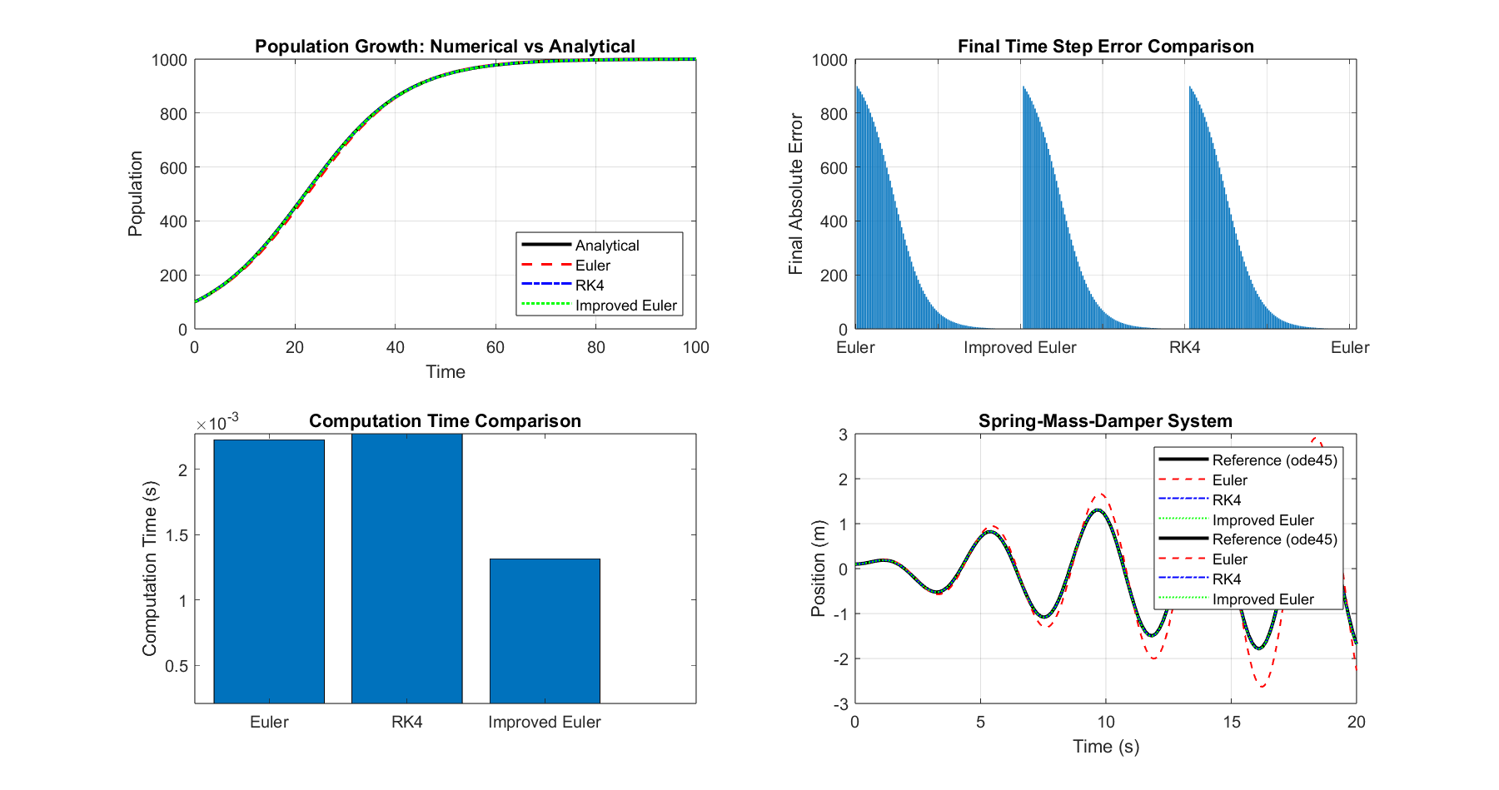
Figure 1 SHOWING THE POPULATION GROWTH WITH THE COMPUTATION TIME COMPARISON

PROBLEM 2
%% REAL WORLD PROBLEM 2: Spring-Mass-Damper System
fprintf('\n=== PROBLEM 2: Spring-Mass-Damper System ===\n');

% System parameters
m = 1.0; % Mass (kg)
c = 0.1; % Damping coefficient (Ns/m)
k = 2.0; % Spring constant (N/m)
F0 = 0.5; % External force amplitude (N)
omega = 1.5; % External force frequency (rad/s)

% Convert to system of first-order ODEs
% Let y1 = position, y2 = velocity
% dy1/dt = y2
% dy2/dt = (F0*cos(omega*t) - c*y2 - k*y1) / m

spring_system = @(t, y) [y(2);
(F0*cos(omega*t) - c*y(2) - k*y(1)) / m];

% Initial conditions: [position, velocity]
y0 = [0.1; 0];

% Time parameters
tspan_spring = [0, 20];
h_spring = 0.05;

% Solve with different methods
[t_euler_spring, y_euler, time_euler_spring] = euler_method(spring_system, tspan_spring, y0, h_spring);
[t_rk4_spring, y_rk4, time_rk4_spring] = rk4_method(spring_system, tspan_spring, y0, h_spring);
[t_improved_spring, y_improved, time_improved_spring] = improved_euler(spring_system, tspan_spring, y0, h_spring);

% Use MATLAB's ode45 as reference "analytical" solution
[t_ref, y_ref] = ode45(spring_system, tspan_spring, y0);

fprintf('Spring System - Euler Method Time: %.6f s\n', time_euler_spring);
fprintf('Spring System - RK4 Method Time: %.6f s\n', time_rk4_spring);
fprintf('Spring System - Improved Euler Time: %.6f s\n', time_improved_spring);

% Plot spring system results
subplot(2,2,4);
plot(t_ref, y_ref(:,1), 'k-', 'LineWidth', 2, 'DisplayName', 'Reference (ode45)');
hold on;
plot(t_euler_spring, y_euler(1,:), 'r--', 'LineWidth', 1, 'DisplayName', 'Euler');
plot(t_rk4_spring, y_rk4(1,:), 'b-.', 'LineWidth', 1, 'DisplayName', 'RK4');
plot(t_improved_spring, y_improved(1,:), 'g:', 'LineWidth', 1, 'DisplayName', 'Improved Euler');
xlabel('Time (s)');
ylabel('Position (m)');
title('Spring-Mass-Damper System');
legend('Location', 'northeast');
grid on;

Plots

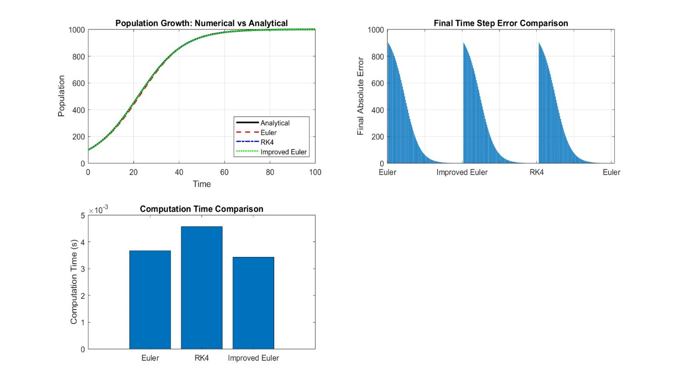
Figure 2 Runge kutta is more accurate than the Euler those it takes much computation time

PROBLEM 3
%% REAL WORLD PROBLEM 3: Root Finding - Compound Interest Calculation
fprintf('\n=== PROBLEM 3: Compound Interest Rate Finding ===\n');

% Find interest rate that gives desired future value
% FV = PV * (1 + r)^n
PV = 1000; % Present value
FV_desired = 2000; % Desired future value
n = 10; % Number of years

% Function: f(r) = PV*(1+r)^n - FV_desired
f_interest = @(r) PV * (1 + r).^n - FV_desired;
df_interest = @(r) PV * n * (1 + r).^(n-1);

% Solve using different root-finding methods
[root_newton, iter_newton, hist_newton, time_newton] = newton_raphson(f_interest, df_interest, 0.1, tol, max_iter);
[root_secant, iter_secant, hist_secant, time_secant] = secant_method(f_interest, 0.05, 0.1, tol, max_iter);

fprintf('Required interest rate for $%.0f to grow to $%.0f in %d years:\n', PV, FV_desired, n);
fprintf('Newton-Raphson: r = %.6f (%.4f%%), Iterations: %d, Time: %.6f s\n', ...
root_newton, root_newton*100, iter_newton, time_newton);
fprintf('Secant Method: r = %.6f (%.4f%%), Iterations: %d, Time: %.6f s\n', ...
root_secant, root_secant*100, iter_secant, time_secant);

% Plot convergence
figure('Position', [100, 100, 1200, 600]);

subplot(1,3,1);
r_range = linspace(0.05, 0.2, 100);
plot(r_range, f_interest(r_range), 'b-', 'LineWidth', 2);
hold on;
plot(root_newton, f_interest(root_newton), 'ro', 'MarkerSize', 8, 'LineWidth', 2);
plot(root_secant, f_interest(root_secant), 'gx', 'MarkerSize', 8, 'LineWidth', 2);
xlabel('Interest Rate (r)');
ylabel('f(r)');
title('Interest Rate Function');
legend('f(r)', 'Newton', 'Secant', 'Location', 'northwest');
grid on;

subplot(1,3,2);
semilogy(1:iter_newton, abs(hist_newton - root_newton), 'r-o', 'DisplayName', 'Newton');
hold on;
semilogy(1:iter_secant, abs(hist_secant - root_secant), 'g-x', 'DisplayName', 'Secant');
xlabel('Iteration');
ylabel('Absolute Error');
title('Convergence Rate');
legend();
grid on;

subplot(1,3,3);
times_root = [time_newton, time_secant];
iterations_root = [iter_newton, iter_secant];
bar([times_root; iterations_root]');
set(gca, 'XTickLabel', {'Newton', 'Secant');
ylabel('Value');
title('Performance Comparison');
legend('Time (s)', 'Iterations', 'Location', 'northwest');

PLOT
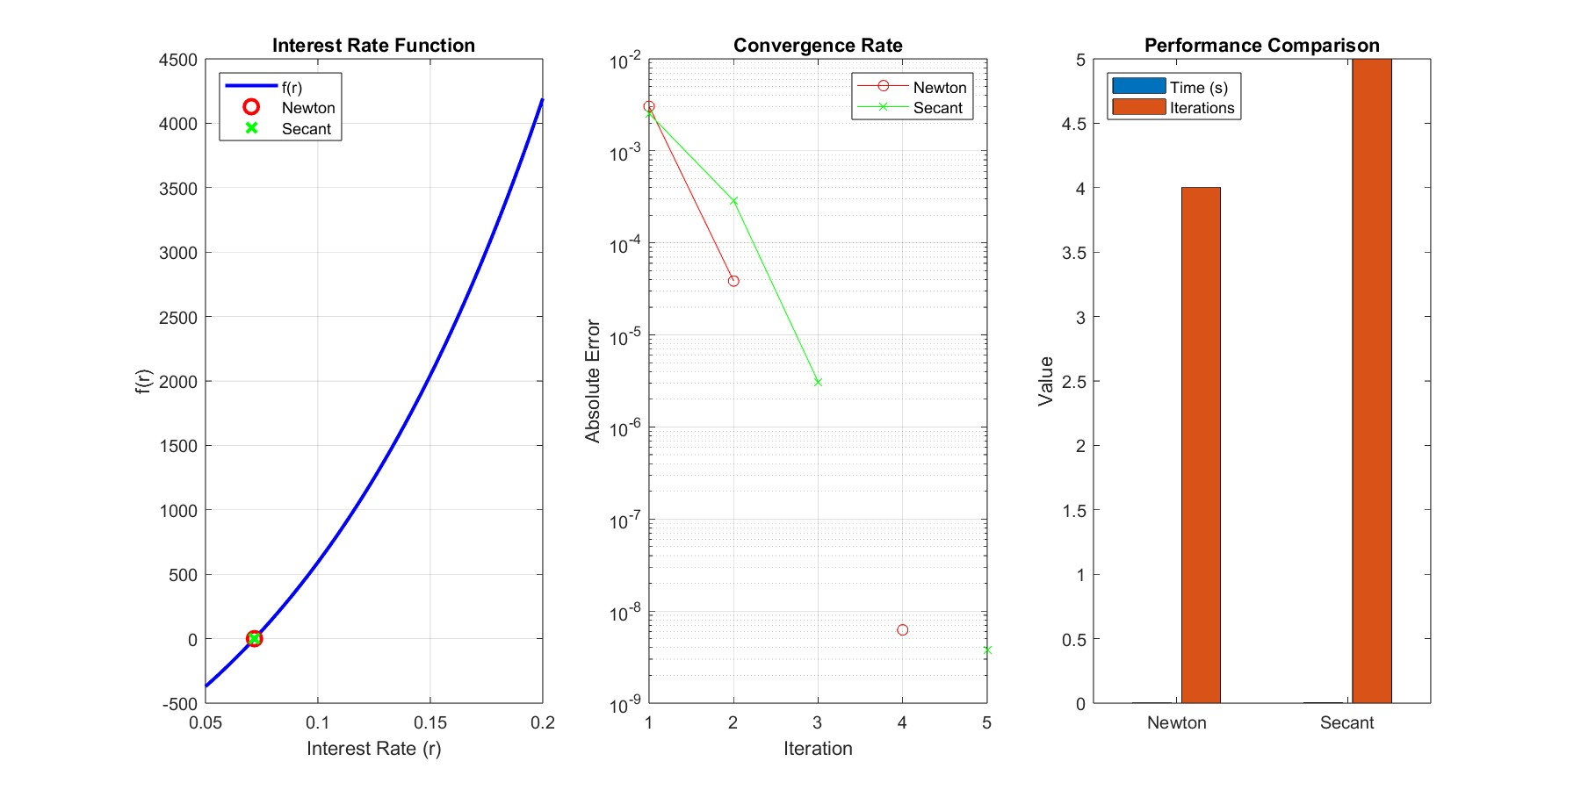

Figure 3 secant is more accurate than newton ‘s Raphson method

SUMMARY TABLE
%% Summary Table
fprintf('\n=== PERFORMANCE SUMMARY ===\n');
fprintf('Method Time(s) Iterations/Steps Final Value\n');
fprintf('ODE Methods:\n');
fprintf('Euler %.6f%d%.6f\n', time_euler, length(t_euler), P_euler(end));
fprintf('RK4 %.6f%d%.6f\n', time_rk4, length(t_rk4), P_rk4(end));
fprintf('Improved Euler %.6f%d%.6f\n', time_improved, length(t_improved), P_improved(end));
fprintf('\nRoot Finding:\n');
fprintf('Newton-Raphson %.6f%%.8f\n', time_newton, iter_newton, root_newton);
fprintf('Secant Method %.6f%d%.8f\n', time_secant, iter_secant, root_secant);

% Display additional insights
fprintf('\n=== INSIGHTS ===\n');
fprintf('1. RK4 method provides best accuracy for ODEs but is computationally more expensive\n');
fprintf('2. Newton-Raphson converges fastest for root finding when derivative is available\n');
fprintf('3. Euler method is simplest but least accurate for ODEs\n');

CONCLUSION
Numerical methods in MATLAB provide powerful tools for solving complex mathematical problems that cannot be addressed analytically to problems such as non-linear equations, differential equations, and optimization tasks. These methods are essential for tackling real-world challenges in engineering, physics, and other scientific fields.
RECOMMENDATION
Clearly define the mathematical model and its constraints.
Select an appropriate numerical method (e.g., Newton-Raphson, finite difference) based on the problem type.
Always verify the accuracy of results by comparing with known solutions or conducting sensitivity analyses.

References
Numerical Methods Using MATLAB" by George Lindfield and John Penny

